|  |  |
| --- | --- |
| Agreement #: 22588  FY18  Level: Quarterly Milestone (Regular)  WBS #: 4.2.1.30 | Completion Date: December 31, 2018  Scheduled Completion: December 31, 2018  Platform Area: Biochemical Conversion |
| Milestone Title: | Identify conditions under which low TRL [technology readiness level] technologies are competitive in the current and future WTE [waste-to-energy] industry. Specific areas of investigation will focus on four areas of interest, as identified from the sensitivity analysis performed in FY18: 1) Maturity tipping point, 2) Disposal costs, 3) Financial parameters around learning, and 4) Inter-regional policy impacts |
| Authors: | Laura Vimmerstedt, Annika Eberle, Dylan Hettinger, Danny Inman |
| Participating Researchers: | NA |
| Project Title:  Principal Investigator: | Waste to Energy System Simulation Model  Daniel Inman |
| Key Words: | Waste to energy, system dynamics |
| Reviewed By: | Steve Peterson, Corey Peck |

We report on a study that explored the impact of twelve model factors on the adoption of hydrothermal liquefaction (HTL) as a waste-to-energy (WTE) technology choice for concentrated animal feeding operations (CAFOs) and publicly owned treatment works (POTWs) in California (CA) and the rest of the United States (ROTUS). HTL is still under development, including U.S. Department of Energy research and development. Two pilot-scale HTL projects are located in Vancouver, British Columbia and Oakland, California, and there are no commercial-scale HTL facilities in operation. Although landfills intake some wet waste that could be used to produce biofuels via HTL, the model used in this study does not currently disaggregate these wet resources from other waste streams. As a result, we excluded landfills from this analysis.

We found that investment in incumbent technologies (e.g., combined heat and power [CHP], compressed natural gas [CNG], electricity, and pipeline natural gas [PNG]) is more common than in less mature technologies. Even so, our model results identify scenarios under which HTL achieves modest levels of adoption. This occurs despite the main impediment to widespread adoption of HTL: its low commercial maturity level. Although important, higher commercial maturity alone does not prompt HTL adoption.

**Background**

The technology investment decision process of the WTE industry differs from that of the biofuels industry because the disposal of waste is a required function of this industry, while energy production is optional. For example, POTWs and CAFOs are required by federal and state laws to treat and/or dispose of the biosolids (manure, sewage sludge) produced as part of their respective operations. For these facilities, the choice to invest in technology that physically reduces the amount of biosolids to be treated amounts to a balance between the technology’s capital and operational investments relative to the avoided costs of waste disposal and any revenues from energy production.

Mature WTE technologies can effectively reduce the amount of biosolids and produce energy. For these technologies, using waste to produce a marketable source of energy offers an additional revenue stream that can help to offset the capital and operational costs of facilities in the WTE industry. The combined incentives of reducing waste disposal costs and generating additional revenue through energy production make investing in WTE technologies attractive to CAFOs and POTWs. However, based on our most recent data (updated in July 2018), more than 99% of CAFOs and POTWs in the United States have still not invested in any WTE technology (less than 1% of CAFOs and POTWs currently have WTE technology installed).

**Approach**

The National Renewable Energy Laboratory (NREL) conducted an analysis to explore the development potential of HTL conversion of wastewater sludge and dairy manure to fungible bio-crude that can be converted, via upgrading, to a hydrocarbon liquid transportation fuel. The technology cost and performance assumptions for HTL are based on the nth plant design case by the Pacific Northwest National Laboratory (2017/PNNL-27186) for biocrude from sludge (see Table 6 of that report).

To perform this analysis, we used the waste-to-energy system simulation model (WESyS), a system dynamics model that tracks WTE technological investments and energy production from landfills, POTWs, and CAFOs in two U.S. regions – CA and ROTUS. The model represents seven technology investment options: no waste-to-energy (NoWTE), capture and flare (CF), CHP, CNG, electricity, PNG, and HTL. The first two of these do not produce energy. Because HTL is still under development, we model it using a lower technical readiness level than the other WTE technologies.

For this study, we used a Sobol quasi-random sequence study design in which we varied twelve model factors (Table 1). The choice of factors was based on previous sensitivity analyses (FY18 Q3 and Q4) as well as our understanding of the model and the system it represents. Using this approach, the study design consisted of 195,000 simulations. After the simulations were run, we performed regression tree analysis on the results with a pruning criterion set to 0.05 (i.e., only factors that explain > 5% of the variance are included in the regression tree). We performed regression tree analysis and examined the time series of energy production by resource, energy type, and region to generate the following insights.

**Table 1. Default values and range of factors included in this analysis.**

|  |  |  |  |  |  |
| --- | --- | --- | --- | --- | --- |
| **Factor** | **Description** | **Units** | **Default** | **Low** | **High** |
| Initial commercial maturity of HTL | Sets initial maturity level for HTL. | - | 0 | 0 | 0.9 |
| RIN multiplier | Multiplied by the base value of the RIN credit, which reaches $2.50 per gallon ethanol equivalent. | - | 1 | 0 | 2 |
| Construction duration multiplier | Determines the lag time from project initiation to completion. | - | 1 | 0.33 | 1.67 |
| Disposal cost | Charge for landfilled waste. | $/tonne | 52.2 | 0 | 450 |
| PTC REC multiplier1 | Multiplied by the base value of the PTC REC, which reaches a maximum of $3.33 per gasoline gallon equivalent for electricity. | - | 1 | 0 | 2 |
| LCFS multiplier | Multiplied by the base value of the LCFS, which ranges from 0 to $180/tonne. | - | 1 | 0 | 2 |
| SB1383 waste influx multiplier | Multiplied by the base fraction of influx diverted from landfills because of SB1383, which ranges from 0 to 0.75. | - | 1 | 0 | 1 |
| SB1383 organic waste to POTWs multiplier | Multiplied by the weight of organic waste that is diverted from landfills due to SB1383. | - | 0.95 | 0 | 0.95 |
| Seeding demo plants start time | Start year of demonstration of technology. | time | 2018 | 2018 | 2022 |
| Seeding demo plants duration | Duration of demonstration of technology. | years | 4 | 1 | 10 |
| Effect of seeding demo plants on maturity for HTL | Determines the influence of demonstration experience on maturity improvement for HTL. | - | 1 | 0 | 5 |
| AEO selector | 3-way choice between reference, high, and low oil prices scenario in the Energy Information Administration’s AEO. | - | 1 (Reference case) | 1, 2, or 3 | |

Abbreviations: HTL = hydrothermal liquefaction; RIN = Renewable Identification Number; PTC REC = Production Tax Credit renewable electricity credit; CHP = combined heat and power; CNG = compressed natural gas; Elec = electricity; PNG = pipeline natural gas; LCFS = California’s Low Carbon Fuel Standard; SB1383 = California Senate Bill 1383; POTWs = publicly owned treatment works; AEO = Annual Energy Outlook.

1 The PTC REC multiplieris only applicable to CHP, CNG, Elec, and PNG; other technologies have zero PTC REC values.

**Summary of Results**

Our objective was to identify key factors that might contribute to the successful commercial deployment of HTL. Based on our analysis, this report presents the following insights:

1. Although the range of values for the twelve key input factors explored in this study generally favors the adoption of incumbent technologies, specific combinations of values lead to modest levels of HTL adoption.
2. Five factors in the analysis explain variance in energy production via HTL; of these, two explain variance in total energy production.
3. The factors that are most important to energy production via HTL relate to different aspects of the WTE supply chain, including WTE technology development, policy incentives, waste management costs, and expenses during construction.
4. The relative importance of these factors varies between CAFOs and POTWs.
5. Simulations with higher energy production via HTL have higher initial commercial maturity of HTL *and* external conditions that favor HTL relative to other investment options.
6. Based on the limited factors and ranges explored, this study did not find evidence of inter-regional policy impacts on the growth of energy production via HTL.

Together, these insights show a narrow path to growth in HTL production, with certain key factors offering the most favorable conditions for HTL growth by advancing HTL technology and limiting competition from other technologies.

**Insight #1. Although the range of values for the twelve key input factors explored in this study generally favors the adoption of incumbent technologies, specific combinations of values lead to modest levels of HTL adoption.**

In this study, we varied twelve key input factors over a wide range of values using a uniform distribution for each (see Table 1 for the list of factors and corresponding parameter ranges). Because we were unable to find adequate data on the empirical distributions of these inputs, we could not estimate the probability of each set of results. However, the results of our analysis with the uniform distributions suggest that the combinations of input values that result in growth in HTL production is rare. Out of 195,000 simulations, only 16,133 (less than 10%) resulted in HTL production that was greater than zero. Figure 1 shows relative (top panel) and total (bottom panel) energy contribution by resource, region, and WTE technology. 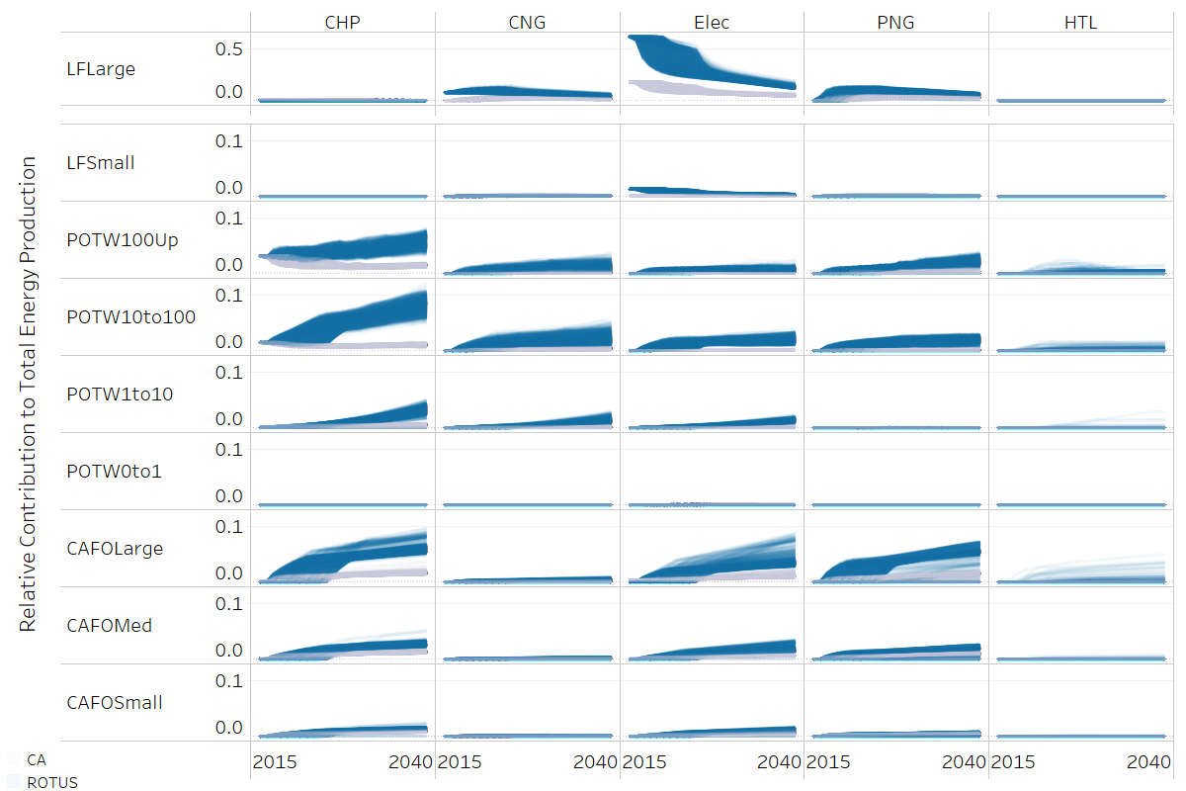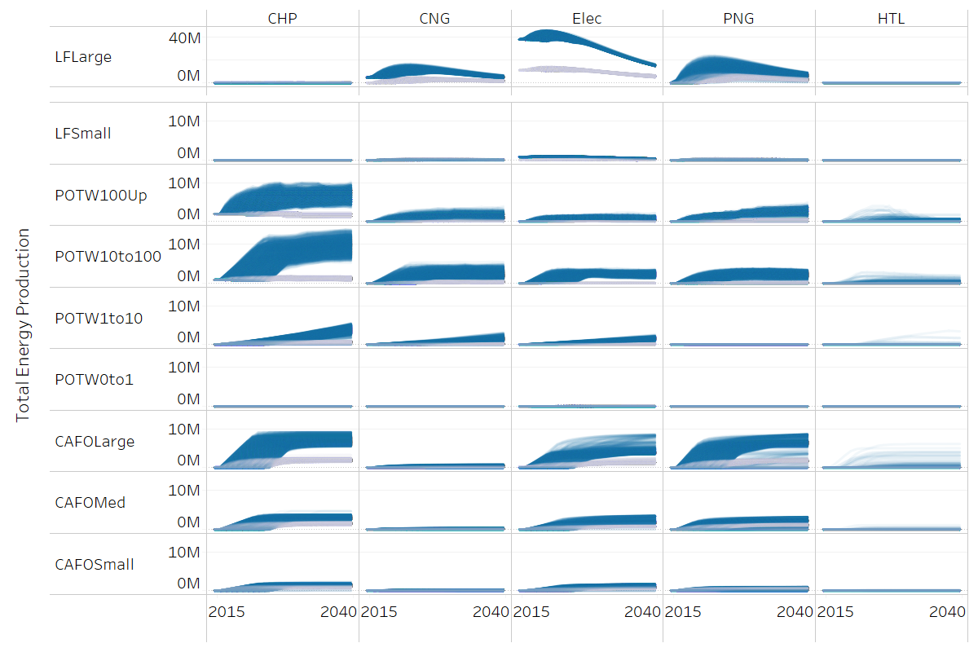

**Figure 1. Relative (top panel; unitless) and total (bottom panel; gigajoules) energy contribution by resource, region, and technology for cumulative energy production from WTE facilities from 2015 to 2040.** Abbreviations: CHP = combined heat and power; CNG = compressed natural gas; Elec = electricity; PNG = pipeline natural gas; HTL = hydrothermal liquefaction; LFLarge, LFSmall = large and small landfills; POTW100Up, POTW10to100, POTW1to10, POTW0to1 = large, medium, small, and very small publicly owned treatment works (POTWs); CAFOLarge, CAFOMed, CAFOSmall = large, medium, and small concentrated animal feeding operations (CAFOs). Note that the scales for LFLarge differ from the scales used for other facility types.

**Insight #2. Five factors in the analysis explain variance in energy production via HTL; of these, two explain variance in total energy production.**

For a factor to be considered important in this study, it must, in combination with all the other factors, explain at least 5% of the total variance of the target output metric (either energy from HTL or total energy). Table 2 ranks the factors that are most important for HTL production and those that are most important for total energy production. These factors include initial commercial maturity of HTL and PTC REC multiplier (for both HTL and total energy production) and RIN multiplier, construction duration multiplier, and disposal cost for HTL only. The mechanisms by which these factors affect energy production, and the reasons for differences between HTL and total energy production, are explored below.

**Table 2. Relative importance of factors for cumulative HTL energy production and total energy production from 2015 to 2040.**

|  |  |  |
| --- | --- | --- |
| **Factor1** | **Explains > 5% of variance2**  **(Rank, 1=most important)** | |
| **…in HTL energy** | **…in total energy** |
| Initial commercial maturity of HTL | 1 | - |
| RIN multiplier | 2 | - |
| Construction duration multiplier | 3 | 2 |
| Disposal cost | 4 | - |
| PTC REC multiplier3 | 5 | 1 |
| LCFS multiplier | - | - |
| SB1383 waste influx multiplier | - | - |
| SB1383 organic waste to POTW multiplier | - | - |
| Seeding demo plants duration | - | - |
| Seeding demo plants start time | - | - |
| Effect of seeding demo plants on maturity for HTL | - | - |
| AEO selector | - | - |

Abbreviations: HTL = hydrothermal liquefaction; RIN = Renewable Identification Number; PTC REC = Production Tax Credit renewable electricity credit; CHP = combined heat and power; CNG = compressed natural gas; Elec = electricity; PNG = pipeline natural gas; LCFS = California’s Low Carbon Fuel Standard; SB1383 = California Senate Bill 1383; POTW = publicly owned treatment works; AEO = Annual Energy Outlook.

1 The “Factor” column lists each of the factors that were varied in this analysis. These were selected based on previous variance-based sensitivity analysis.

2 The “Explains > 5% of variance” columns show the relative importance of each of the factors, in combination with other factors varied in the study, that explain more than 5% of the variance in HTL energy production (left) or total energy production (right). Dashes are used to indicate that a factor does not explain more than 5% of the total variance of the target metric (either energy from HTL or total energy).

3 The PTC REC multiplier is only applicable to CHP, CNG, Elec, and PNG; other technologies have zero PTC REC values.

**Insight #3. The factors that are most important to energy production via HTL relate to different aspects of the WTE supply chain, including WTE technology development, policy incentives, waste management costs, and expenses during construction.**

The factors that are most important to HTL production relate to WTE technology development (initial commercial maturity of HTL), policy incentives (the RIN multiplier and the PTC REC multiplier), the waste management costs (disposal cost), and expenses during construction (construction duration multiplier). Figure 2 shows where these factors fall on a generic diagram of the WTE supply chain. Table 3 shows each factor with an explanation of the mechanism by which it influences HTL production and the related default values from the model.

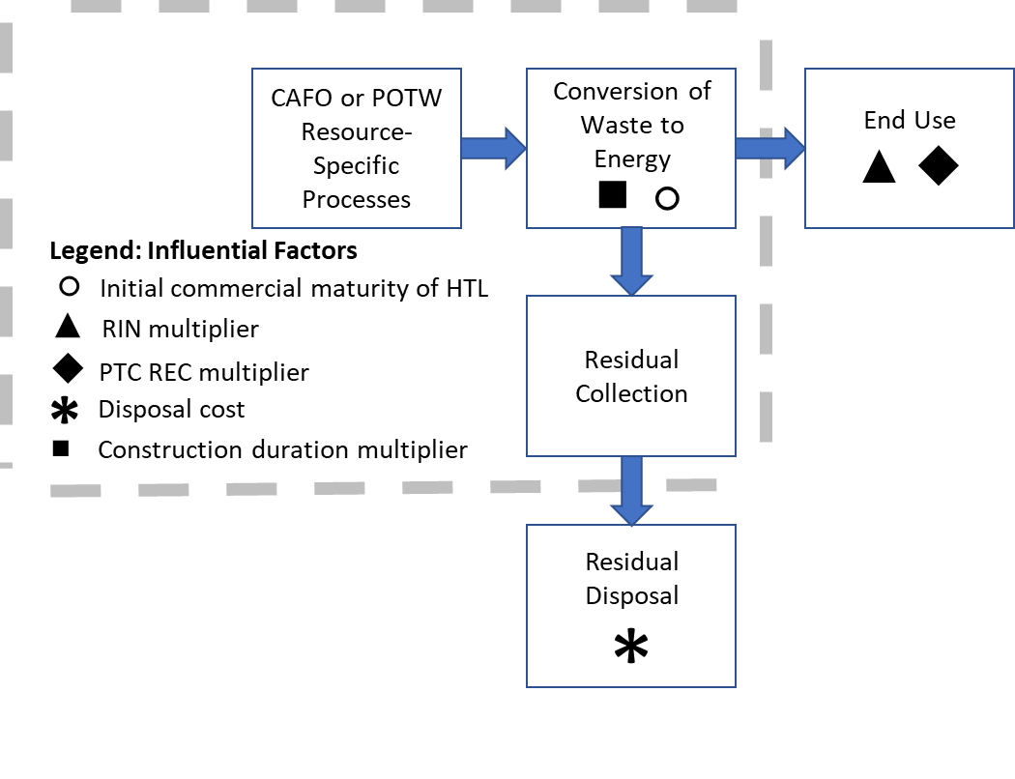

**Figure 2. Position of influential factors in supply chain.** Abbreviations: CAFO = concentrated animal feeding operation; POTW = publicly owned treatment work; RIN = Renewable Identification Number; PTC REC = Production Tax Credit renewable electricity credit; HTL = hydrothermal liquefaction.

**Table 3. Supply chain element and mechanism of effect for most important factors (F), along with weighting parameters (W).**

|  |  |  |  |  |  |  |  |  |  |  |  |
| --- | --- | --- | --- | --- | --- | --- | --- | --- | --- | --- | --- |
| **Supply chain element** | **Factor (F) that is important to energy production (default value in parentheses)1** | **Mechanism by which factor impacts energy production** | **Weighting parameter (W)**  **that gets influenced by factor F2** | **Default value of W (by technology type)** | | | | | | | **Impact on energy production3** |
| **No** | **CF** | **CHP** | **CNG** | **Elec** | **PNG** | **HTL** |
| WTE technology development | Initial commercial maturity of HTL (0) | Increase directly improves competitiveness of HTL | initial commercial maturity (unitless) | 1 | 1 | 1 | 1 | 1 | 1 | 0 | Energy is function of factor alone (W = F) |
| policy incentives for fuels | RIN multiplier (1) | Increase favors technologies receiving RIN value | RIN incentive  ($/GGE) | 0 | 0 | 0 | 2.7 | 1.7 | 0 | 2.8 | Energy production is function of W * F |
| expenses during construction | Construction duration multiplier (1) | Decrease favors higher-capital-cost technologies | capital cost  (rank; 1 = high) | 7 | 6 | 4-5 | 2-3 | 4-5 | 2-3 | 1 | Energy production is function of W and F |
| waste management costs | Disposal cost ($ 52.2) | Increase favors technologies that reduce biosolids disposal requirements | waste conversion efficiency (%) | 0 | 0 | 0.5 | 0.5 | 0.5 | 0.5 | 0.86 | Energy production is function of W and F |
| policy incentives for electricity | PTC REC multiplier (1) | Decrease favors technologies with no electricity production | PTC REC value ($/GGE) | 0 | 0 | 3.3 | 2.6 | 3.3 | 2.6 | 0 | Energy production is function of W * F |

Abbreviations: WTE = waste-to-energy; HTL = hydrothermal liquefaction; RIN = Renewable Identification Number; PTC REC = Production Tax Credit renewable electricity credit; No = no waste-to-energy technology; CF = capture and flare; CHP = combined heat and power; CNG = compressed natural gas; Elec = electricity; PNG = pipeline natural gas; GGE = gasoline gallon equivalent.

1 Factors were identified as among the most important if, in combination with the other study factors (Table 1), they explain greater than 5% of the variance in energy production from HTL.

2 The weighting parameters (W) mediate the effect of the factor (F) on energy production.

3 The last column illustrates how the factors interact to impact energy production. In general, our analysis does not include changes in the relative weight across technologies; relative initial commercial maturity is the exception.

**Insight #4. The relative importance of these factors varies between CAFOs and POTWs.**

Among the five factors that were identified as being important to HTL production, the relative importance of these factors varies, primarily based on CAFO or POTW resource availability and energy demand (Table 4). Initial commercial maturity of HTL is the most important factor for HTL production for both CAFO and POTW resources. However, for the remaining factors, rank differs between POTW and CAFO resources, primarily because of the assumption that POTWs have greater access to end-use markets for CNG. For POTWs, the remaining factors are RIN multiplier, PTC REC multiplier, and construction duration multiplier, whereas for CAFOs they are construction duration multiplier, RIN multiplier, and disposal cost. The RIN multiplier is ranked higher at POTWs because RINs provide a strong incentive for CNG production and POTWs have greater CNG production.

The differences in rank by region for all resources reflects the relative energy shares of the two resources in the two regions. The All Resources, CA ranking pattern matches the CAFO pattern because CAFOs are the greater energy resource in California, and the All Resources, ROTUS ranking represents a blend of the two resource patterns. Similarly, the All Resources, US rankings represents a blend of the ROTUS and CA resource patterns.

**Table 4. Importance rank for cumulative total energy for all resources and HTL energy by resource and region from 2015 to 2040.**

|  |  |  |  |  |  |  |  |  |
| --- | --- | --- | --- | --- | --- | --- | --- | --- |
| **Factor Name** | **Importance Rank by Energy Type, Resource Type, and Region** | | | | | | | |
| **HTL** | | | | | | | **Total Energy** |
| *All Resources*  *(CAFO + POTW)* | | | *CAFO* | | *POTW* | | *All Resources*  *(CAFO + POTW + LF)* |
| **US** | **ROTUS** | **CA** | **ROTUS** | **CA** | **ROTUS** | **CA** | **US** |
| Initial commercial maturity of HTL | 1 | 1 | 1 | 1 | 1 | 1 | 1 |  |
| RIN multiplier | 2 | 2 | 3 | 3 | 3 | 2 | 2 |  |
| Construction duration multiplier | 3 | 3 | 2 | 2 | 2 | 4 | 4 | 2 |
| Disposal cost | 4 |  | 4 | 4 | 4 |  |  |  |
| PTC REC multiplier | 5 | 4 |  |  |  | 3 | 3 | 1 |

Abbreviations: CAFO = concentrated animal feeding operation; POTW = publicly owned treatment works; LF = landfill; US = entire United States.; CA = California; ROTUS = rest of the United States [everything except CA].

**Insight #5. Simulations with higher energy production via HTL** **have higher initial commercial maturity of HTL *and* external conditions that favor HTL relative to other investment options.**

Figure 3 shows a regression tree generated for total energy production from HTL, which indicates how the values of important factors are distinguished for simulations with the greatest HTL production. Each box in the figure quantifies the average HTL production and number of simulations in a particular set of the simulations from the study. The boxes that are farthest to the right in each row represent the simulations with greater HTL production. The factors that are towards the top of the figure are most important to HTL energy production. For example, initial commercial maturity of HTL is the highest ranked factor because it is the criterion at the first split of the simulations into two groups (the righthand branch has higher initial commercial maturity and therefore more favorable conditions for HTL and greater HTL production). In addition to having a higher initial commercial maturity of HTL, cases with very high total HTL production (bottom right corner of Figure 3) occur when HTL investment conditions are favorable relative to other options (higher RIN multiplier, lower construction duration multiplier, higher disposal cost, lower PTC REC multiplier).



**Figure 3. Regression tree for total energy production from HTL.** Only factors that explain > 5% of the variance in total HTL production are included. Values inside the boxes indicate the average energy production from HTL (Avg. GJ HTL) and the total number of samples (n) for all of the simulations within that part of the tree. Under each box is a criterion that is applied to divide its set of simulations into two groups (yes = left branch; no = right branch). Coloring shows the average energy production from HTL (red = low; yellow = moderate; green = high). Abbreviations: RIN = Renewable Identification Number; and PTC REC = Production Tax Credit renewable electricity credit; and GJ = gigajoule.

Consistent with the regression tree in Figure 3, the right panel of Figure 4 shows that simulations where HTL contributes to more than 2% of total energy production (High HTL) have very high initial commercial maturities for HTL, along with higher RIN multipliers and disposal costs and lower construction duration multipliers and PTC REC multipliers than cases where HTL produces less than or equal to 2% of total energy (Other). As shown in the left of Figure 4, the relative contribution to total energy production for each of the five WTE technologies varies between the High HTL and Other cases. For example, High HTL cases have relatively lower energy production of CHP and PNG and higher production of CNG.

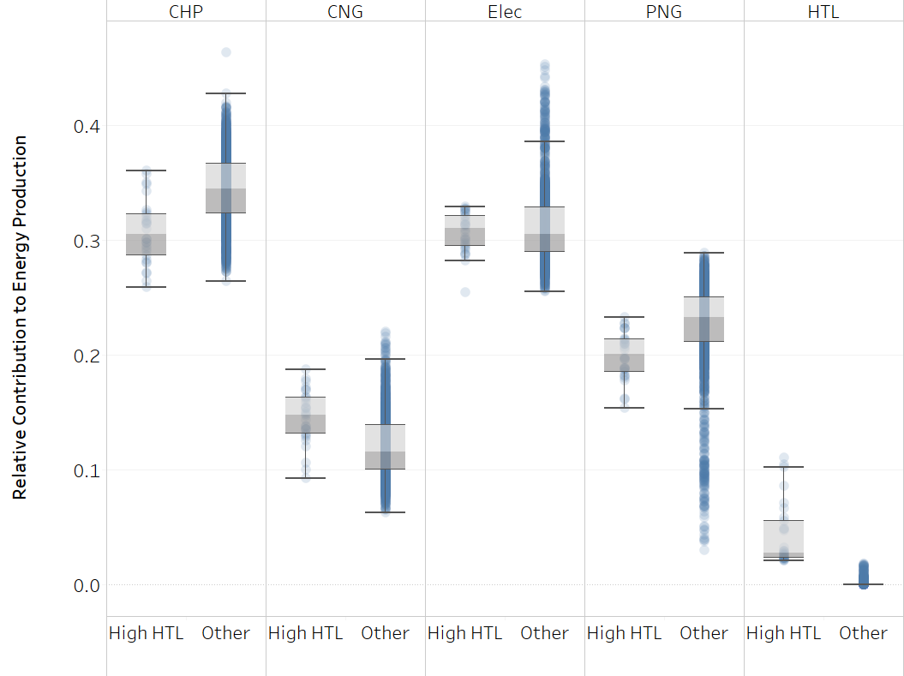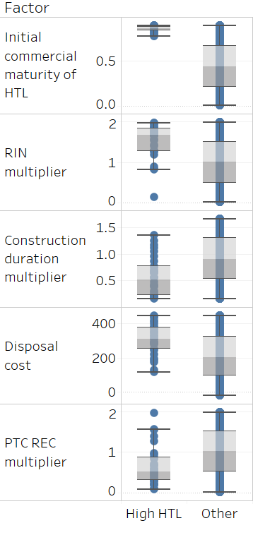

**Figure 4. Simulations where hydrothermal liquefaction (HTL) contributes to more than 2% of total energy production (labeled High HTL) have lower production of combined heat and power (CHP) and pipeline natural gas (PNG) and higher production of compressed natural gas (CNG) than cases where HTL produces less than or equal to 2% of total energy (labeled Other).** Each vertical line consists dots, each of which represents a single simulation from a 1% sample of the simulation results. The gray shading shows the middle two quartiles, with the median falling on the dividing line between the two shades. The other two bars show the 5th and 95th percentiles. The left panel shows the relative contribution to total energy; the right panel indicates how the distribution of factor values varies between the High HTL and Other cases. Abbreviations include: CHP = combined heat and power; CNG = compressed natural gas; Elec = electricity; PNG = pipeline natural gas; HTL = hydrothermal liquefaction; RIN = Renewable Identification Number; and PTC REC = Production Tax Credit renewable electricity credit.

These conditions favor HTL for several reasons. First, because we assume that CNG, Electricity, and HTL all receive RIN credits (even though HTL has not yet been approved to receive RIN credits), higher RIN values favor CNG and Electricity as well as HTL and decrease the relative investment attractiveness of CHP and PNG. Accordingly, CNG and Electricity do not have lower median production in high HTL cases, while CHP and PNG do. Second, lower construction durations favor investment in technologies with higher capital costs, such as HTL. Third, higher disposal costs favor HTL because it has the highest WTE conversion rate and therefore has the greatest advantage when disposal costs increase. Finally, lower PTC REC values in the High HTL cases decrease the relative investment attractiveness of electricity. Thus, the High HTL cases appear to occur when favorable investment conditions exist for HTL—intrinsically (higher initial commercial maturity of HTL) and relative to other investment options (as summarized in the “Mechanism” column of Table 3).

**Insight #6. Based on the limited factors and ranges explored, this study did not find evidence of inter-regional policy impacts on the growth of energy production via HTL.**

One initial hypothesis was that regional policies in California might be important to overall growth in HTL production. However, California policies (LCFS, SB1383) did not rank among those explaining 5% or more of the variance along with other factors. As a result, we conclude that this test does not show evidence of inter-regional policy impacts on the growth of HTL production. There could be other tests of importance or less stringent criteria for importance that would show evidence of inter-regional policy impacts.

**Conclusions**

WTE technology choice, which is represented in the WESyS model, differs from biofuels industry technology choice because waste disposal is obligatory for waste facilities, but not for biofuel producers. This study explored the impact of twelve model factors on the adoption of HTL as a WTE technology and found specific conditions under which HTL gains modest production at CAFOs and POTWs in California and the rest of the United States. This analysis informs WTE technology selection at an opportune moment because most CAFOs and POTWs have not yet installed WTE technologies and HTL, despite its pre-commercial status, offers certain technical advantages relative to other candidate technologies. WTE projects are sited at over 350 CAFOs and POTWs, a minority of the total facilities, and the technologies used to date – CNG, CHP, electricity, and PNG – are favored for selection at the remaining sites. Even so, we have identified scenarios under which HTL achieves modest levels of adoption.

Our analysis of key factors for HTL production indicate a narrow set of conditions that lead to higher HTL production. These conditions target HTL specifically by increasing the initial commercial maturity for HTL, and also shape background conditions that affect other WTE pathways to favor HTL relative to other WTE technologies. A direct increase in the initial commercial maturity of HTL results in the greatest gains for that technology. However, because of the relative immaturity of HTL and competition with other technologies, there is a tradeoff between maximizing total energy produced via WTE and total energy produced via HTL. The highest-ranking factor that is important for HTL production is its initial commercial maturity, indicating the paramount importance of greater technology maturity. The highest-ranking factor for total energy production, on the other hand, is the PTC REC value, because of the large predominance of electricity production from landfill gas.

It is important to note that the factors that influence investment in new technologies in the WTE industry differ from the biofuels industry because waste disposal is obligatory for waste facilities, but not necessarily required for biofuel production, and fuel production is a secondary objective for CAFOs and POTWs but a primary one for biofuel producers.